ЛАБОРАТОРНА РОБОТА №8

ТЕМА: СТИЛІ І ТРИГЕРИ В WPF

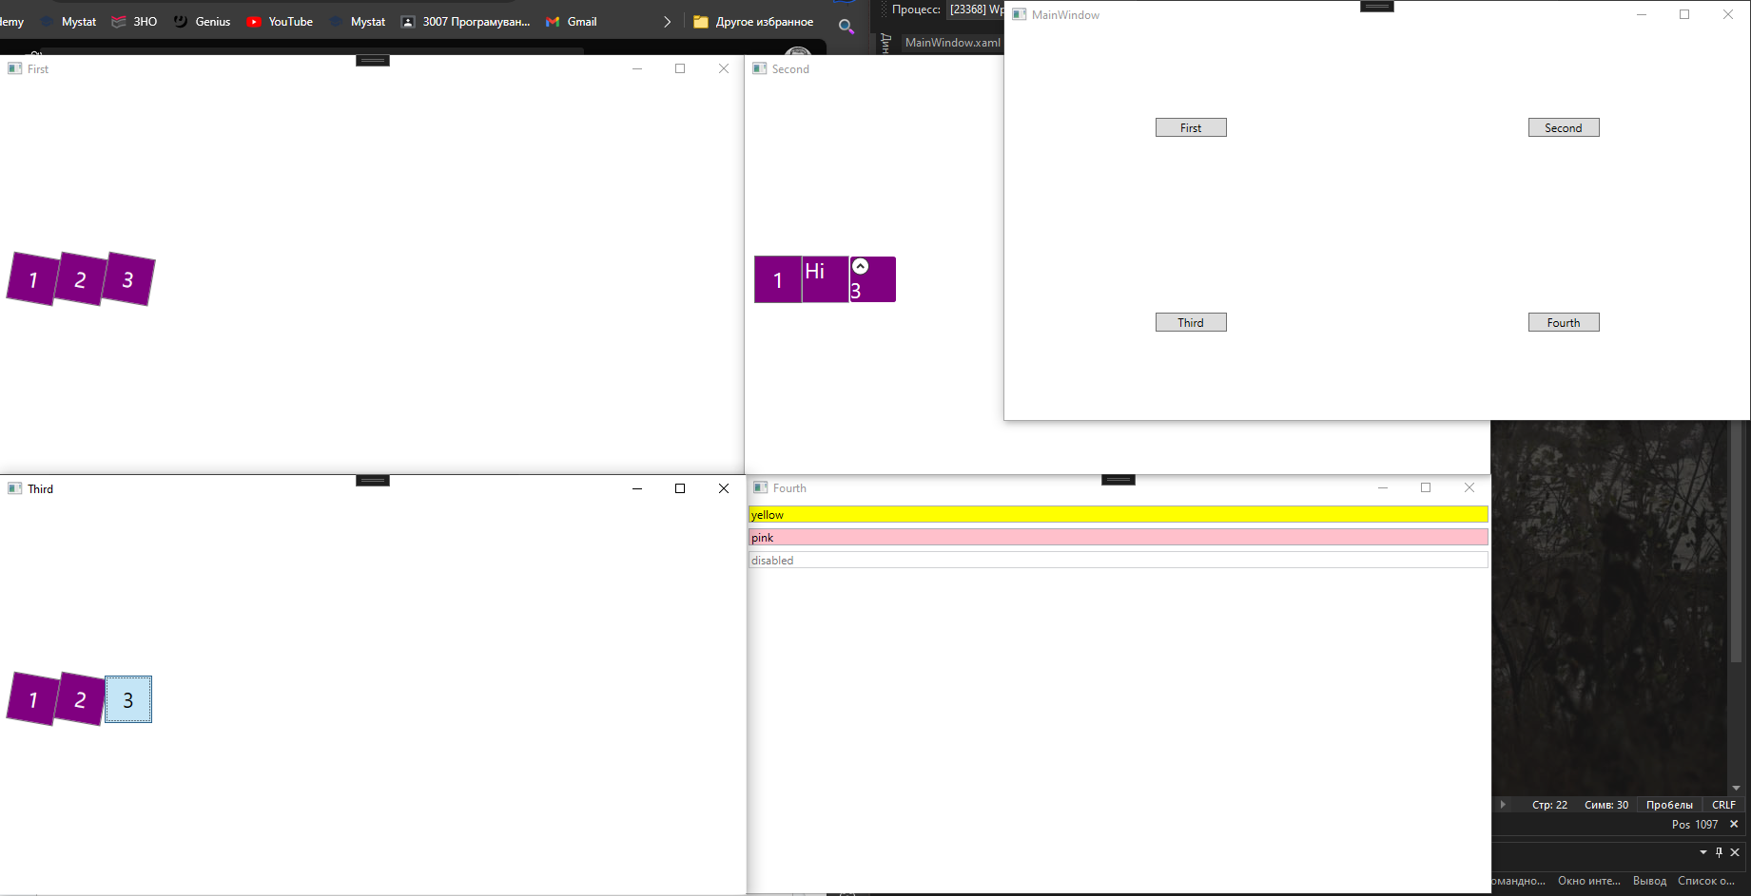

| MainWindow.xaml |
| --- |
| <Window x:Class="WpfApp7.MainWindow"  xmlns="http://schemas.microsoft.com/winfx/2006/xaml/presentation"  xmlns:x="http://schemas.microsoft.com/winfx/2006/xaml"  xmlns:d="http://schemas.microsoft.com/expression/blend/2008"  xmlns:mc="http://schemas.openxmlformats.org/markup-compatibility/2006"  xmlns:local="clr-namespace:WpfApp7"  mc:Ignorable="d"  Title="MainWindow" Height="450" Width="800">  <Grid>  <Grid.RowDefinitions>  <RowDefinition Height="*"/>  <RowDefinition Height="*"/>  </Grid.RowDefinitions>  <Grid.ColumnDefinitions>  <ColumnDefinition Width="*"/>  <ColumnDefinition Width="*"/>  </Grid.ColumnDefinitions>  <Button Grid.Row="0" Grid.Column="0" Content="First" HorizontalAlignment="Center" VerticalAlignment="Center" Width="75" Click="Click"/>  <Button Grid.Row="0" Grid.Column="1" Content="Second" HorizontalAlignment="Center" VerticalAlignment="Center" Width="75" Click="Click"/>  <Button Grid.Row="1" Grid.Column="0" Content="Third" HorizontalAlignment="Center" VerticalAlignment="Center" Width="75" Click="Click"/>  <Button Grid.Row="1" Grid.Column="1" Content="Fourth" HorizontalAlignment="Center" VerticalAlignment="Center" Width="75" Click="Click"/>  </Grid>  </Window> |

| MainWindow.xaml.cs |
| --- |
| using System;  using System.Collections.Generic;  using System.Linq;  using System.Text;  using System.Threading.Tasks;  using System.Windows;  using System.Windows.Controls;  using System.Windows.Data;  using System.Windows.Documents;  using System.Windows.Input;  using System.Windows.Media;  using System.Windows.Media.Imaging;  using System.Windows.Navigation;  using System.Windows.Shapes;  namespace WpfApp7  {  /// <summary>  /// Логика взаимодействия для MainWindow.xaml  /// </summary>  public partial class MainWindow : Window  {  public MainWindow()  {  InitializeComponent();  }  private void Click(object sender, RoutedEventArgs e)  {  Button btn = (Button)sender;  Win1 win1 = new Win1();  Win2 win2 = new Win2();  Win3 win3 = new Win3();  Win4 win4 = new Win4();  switch (btn.Content.ToString())  {  case "First":  win1.Title = "First";  win1.Show();  break;  case "Second":  win2.Title = "Second";  win2.Show();  break;  case "Third":  win3.Title = "Third";  win3.Show();  break;  case "Fourth":  win4.Title = "Fourth";  win4.Show();  break;  }  }  }  } |

| Win1.xaml |
| --- |
| <Window x:Class="WpfApp7.Win1"  xmlns="http://schemas.microsoft.com/winfx/2006/xaml/presentation"  xmlns:x="http://schemas.microsoft.com/winfx/2006/xaml"  xmlns:d="http://schemas.microsoft.com/expression/blend/2008"  xmlns:mc="http://schemas.openxmlformats.org/markup-compatibility/2006"  xmlns:local="clr-namespace:WpfApp7"  mc:Ignorable="d"  Title="Win1" Height="450" Width="800">  <StackPanel Orientation="Horizontal" Margin="10">  <StackPanel.Resources>  <Style x:Key="buttonStyle">  <Setter Property="Button.FontSize" Value="22"/>  <Setter Property="Button.Background" Value="Purple"/>  <Setter Property="Button.Foreground" Value="White"/>  <Setter Property="Button.Height" Value="50"/>  <Setter Property="Button.Width" Value="50"/>  <Setter Property="Button.RenderTransformOrigin" Value=".5, .5"/>  <Setter Property="Button.RenderTransform">  <Setter.Value>  <RotateTransform Angle="10"/>  </Setter.Value>  </Setter>  </Style>  </StackPanel.Resources>  <Button Style="{StaticResource buttonStyle}">1</Button>  <Button Style="{StaticResource buttonStyle}">2</Button>  <Button Style="{StaticResource buttonStyle}">3</Button>  </StackPanel>  </Window> |

| Win2.xaml |
| --- |
| <Window x:Class="WpfApp7.Win2"  xmlns="http://schemas.microsoft.com/winfx/2006/xaml/presentation"  xmlns:x="http://schemas.microsoft.com/winfx/2006/xaml"  xmlns:d="http://schemas.microsoft.com/expression/blend/2008"  xmlns:mc="http://schemas.openxmlformats.org/markup-compatibility/2006"  xmlns:local="clr-namespace:WpfApp7"  mc:Ignorable="d"  Title="Win2" Height="450" Width="800">  <StackPanel Orientation="Horizontal" Margin="10">  <StackPanel.Resources>  <Style x:Key="controlStyle">  <Setter Property="Control.FontSize" Value="22"/>  <Setter Property="Control.Background" Value="Purple"/>  <Setter Property="Control.Foreground" Value="White"/>  <Setter Property="Control.Height" Value="50"/>  <Setter Property="Control.Width" Value="50"/>  </Style>  </StackPanel.Resources>  <Button Style="{StaticResource controlStyle}" Content="1"/>  <TextBox Style="{StaticResource controlStyle}" Text="Hi"/>  <Expander Style="{StaticResource controlStyle}" Content="3"/>  </StackPanel>  </Window> |

| Win3.xaml |
| --- |
| <Window x:Class="WpfApp7.Win3"  xmlns="http://schemas.microsoft.com/winfx/2006/xaml/presentation"  xmlns:x="http://schemas.microsoft.com/winfx/2006/xaml"  xmlns:d="http://schemas.microsoft.com/expression/blend/2008"  xmlns:mc="http://schemas.openxmlformats.org/markup-compatibility/2006"  xmlns:local="clr-namespace:WpfApp7"  mc:Ignorable="d"  Title="Win3" Height="450" Width="800">  <Window.Resources>  <Style x:Key="buttonStyle" TargetType="Button">  <Setter Property="FontSize" Value="22"/>  <Setter Property="Background" Value="Purple"/>  <Setter Property="Foreground" Value="White"/>  <Setter Property="Height" Value="50"/>  <Setter Property="Width" Value="50"/>  <Setter Property="RenderTransformOrigin" Value=".5, .5"/>  <Setter Property="RenderTransform">  <Setter.Value>  <RotateTransform Angle="10"/>  </Setter.Value>  </Setter>  <Style.Triggers>  <Trigger Property="IsMouseOver" Value="True">  <Setter Property="Foreground" Value="Black"/>  <Setter Property="RenderTransform">  <Setter.Value>  <RotateTransform Angle="0"/>  </Setter.Value>  </Setter>  </Trigger>  </Style.Triggers>  </Style>  </Window.Resources>  <StackPanel Orientation="Horizontal" Margin="10">  <Button Style="{StaticResource buttonStyle}">1</Button>  <Button Style="{StaticResource buttonStyle}">2</Button>  <Button Style="{StaticResource buttonStyle}">3</Button>  </StackPanel>  </Window> |

| Win4.xaml |
| --- |
| <Window x:Class="WpfApp7.Win4"  xmlns="http://schemas.microsoft.com/winfx/2006/xaml/presentation"  xmlns:x="http://schemas.microsoft.com/winfx/2006/xaml"  xmlns:d="http://schemas.microsoft.com/expression/blend/2008"  xmlns:mc="http://schemas.openxmlformats.org/markup-compatibility/2006"  xmlns:local="clr-namespace:WpfApp7"  mc:Ignorable="d"  Title="Win4" Height="450" Width="800">  <StackPanel>  <StackPanel.Resources>  <Style TargetType="{x:Type TextBox}">  <Style.Triggers>  <DataTrigger Binding="{Binding RelativeSource={RelativeSource Self}, Path=Text}" Value="disabled">  <Setter Property="IsEnabled" Value="False"/>  </DataTrigger>  </Style.Triggers>  <Setter Property="Background" Value="{Binding RelativeSource={RelativeSource Self}, Path=Text}"/>  </Style>  </StackPanel.Resources>  <TextBox Margin="3"/>  <TextBox Margin="3"/>  <TextBox Margin="3"/>  </StackPanel>  </Window> |